Hey gang,

This is a compilation of all the things you might find to be useful for your Uganda International Health Elective. We didn't have a lot of this information before arriving or it was in bits and pieces so it is sort of a "what we wish we had" sort of format. It is setup so you can add comments (questions) and I will try to find out the information for you and continue to integrate it into the document. I will try to keep it somewhat organized as I collect more information, so you can find information in sections. This is obviously a work in progress, so bear with me. Blue = Morgan's personal take/comment just as an example of what I did (by no means the be-all, end-all - just so you can learn from my mistakes ;P).

LIVING QUARTERS
Gulu House (home base)
>address: Plot 8, Peter Paul Opok Road, Laroo Division, Gulu Municipality, Gulu, Northern Uganda - this is where the troops should be sent to look for your body should your housemates suffocate you in your sleep.
>description: the wing of the house that we are in is a 3-bedroom, single bathroom (split shower and toilet, with sink outside) layout attached to a garage (storage) which is sandwiched by another wing of the house used by the Manchester people (I think it is slightly smaller in size). The Manchester bungalow doesn’t have a stove so you’ll be eating together at times. They have their own fridge, shower and toilet. Two of the rooms (closest to the washroom) actually have 2 beds in each, but there should really be enough space for everyone to have their own room - although this really depends on how many Manchester people are also there at any given time. The toilet flushes, so you don't have to worry about practicing your squats ahead of time for the long drops... although those do exist in other places. The shower is adequate - it has it's own hot water boiler, so as long as you have electricity, you will be fine and have hot water available for showers. If you are anything like me, you will just shower at the Bomah Hotel gym (see section below). Although there is no running water some of the time, there are water reservoirs on towers that supply a sink and the shower, so there is always some water to be had (so far). All of the beds have mosquito nets, although there are a few holes that you might want to bring tape, etc. to be prepared for. By and large, we have not had a huge problem with mosquitoes during the dry season. This will probably be a bit different when it starts to rain.
>critters: Bring some thick skin - aside from the expected mosquitos, there are also a few resident spiders, ants, lizards (mostly stay outside), cockroaches, and a garden pet tortoise (his name is Blair, but Meghan insisted on renaming him Clive…)!

Personnel
>housekeeper: during the weekdays, Agnes is the main housekeeper and her counterpart is currently Suzanne - between the two of them they handle general duties like cleaning the house, toilet, washing dishes, and doing laundry. Laundry is done daily and is pretty reliable, however, I would caution against bringing anything fragile as we have all experienced some... warping of some of our clothes. Just bring enough clothes to get you through a week as well as a weekend trip and you should be more than fine. If you are nice and leave them money, they can do simple grocery shopping for you. We had them buy us a loaf of bread so we could add butter and peanut butter to for breakfast. Agnes will also cook dinner for 15,000 UGX. We did this a few times, but between that cost and the cost of buying groceries, it turned out to be very similar to eating out, so we stopped. It comes in handy if you just want dinner ready when you arrive home.
>day "guard" + handyman: Denis is your all-round go-to guy for any gardening/house repair needs during the weekdays. He will run out and do little tasks for you (e.g. he bought and changed light bulbs, he bought water, crates of beer and sodau for us). He is pretty awesome overall and is always happy. Always. If he is ever not happy, it means the world is coming to an end.
>night guard (7pm - 7am): Francis is the guard who mans the gate at night and is a boda (motorcycle transport) driver by day. He sleeps in the little shed by the gate. It's good to introduce yourself to him early so he recognizes your voice, etc. so when you come home late you don't have to fiddle with your keys and he can just open the gate for you when you Marco-Polo him.
>kitty/float: there is a little tupperware for everyone to contribute money into for groceries, consumables, etc. that you all pitch in for - this is where the house personnel will look for money to make purchases you ask of them. You will mostly be paying for shared water/toilet paper/breakfast groceries unless you also want dinners cooked.
>communication book: there is a little grey book that we leave messages to Agnes in to ask her to get stuff for us, etc. She's pretty good about reading it and trying her best to get what we ask for. Sometimes I draw pictures in there and she draws me pictures back :).

Power
>plugs: all of Uganda uses British 3-prong "square" plugs (I believe they are "G" format) so be sure you bring appropriate travel adapters. There are a few generic power bars and converters in the house, but the safest thing is to obtain your own. I picked up a set for worldwide travel from Bentley for $14 that has done the trick really well. I would also encourage bringing a small power (or surge) bar so you can support multiple devices at once AND it would serve to protect your devices when they are charging in the midst of multiple power outtages. Overall, not required, but I would highly recommend it as it would make your life easier, and depending on what other devices you’ve brought, might really allow you to take advantage of the times you DO have power, using only a single plug adapter.
Janet: There are actually quite a few power bars at the house now, just make sure you have enough adapters. Also do NOT plug in a Canadian power bar into an outlet here, it will blow out.

>electricity: this can be very intermittent and gets worse as you head into the wet season. As it stands, I started to write this while we had been powerless for 24-hours for a total duration of ~38-hours (the longest by far). I have been told that power outages can last ~48 hours, so you might want to be prepared for this and bring a backup battery for your integral devices. We have been fairly fortunate, and have only had 5 power outages in 3 weeks - all of the previous ones lasting ~12-hours (update: in our last week, we had 5 power outages). I would suggest bringing a flashlight that can also double as a lantern - i.e. that can stand up independently on its own - for lighting your room, tent, washroom, etc. during those power-free periods. The power once unanticipatedly went out when I was IN the shower... which made things go from relaxed to extremely distressing in a short amount of time as I had to fondle my way out and back to my room in absolute darkness… while stark naked.
>but I really need power!: Of course, I have already sourced out a solution to this should you REALLY need power. If that's the case, head over to the Bomah Hotel - they will always have power running via generators and wifi will also be up in their restaurant (see below for Bomah Hotel details).

TECHNOLOGY
Telecommunications
Make sure your phone is unlocked before you leave Canada (I got my Bell-locked Samsung S4 unlocked for $39.20 @ VanCell Repairs - it takes 24-hours and the guy was pretty helpful). You can also unlock your phone online if you google it.
There is one burner phone but it doesn’t look Canadian, I think those have migrated. There are a couple of Sim cards in the boxes but they are empty. SIM cards are super cheap 500-2000 UGX each and can be bought anywhere.
There are many many cell phone companies: Orange, MTN, Airtel etc. As you see if you are all on one provider it is a bit cheaper to call each other. Note that MTN has the best coverage outside of the cities, followed by Airtel. So if you want to stay connected if you’re travelling to farflung regions of the country (eg. Kidepo) you might want to consider MTN. The modem is Orange and other groups have also used Orange, which makes it easy to trouble shoot for each other. However you can compare online the different rates and packages each company has.

The Orange shop sells SIMs and microSIMs, other shops can cut them for you. Note that Orange is changing its name to “Africell” so the SIM cards say that. The Website for Orange is still orange.ug and will give you all the available info on packages of data, mobile airtime, etc.
The shop can set you up and help you add time, buy data packages or super combos but there can be a bit of a lineup at the shop and you can input it yourself.

The Orange Telecom Service Shop is just up the main road of the city on the left side, (see map) half a block from Crane Bank (hours: Mon-Sat 8:30am - 6:00pm); you can’t miss it (see picture)- unlike many of the shacks with Orange/MTN signs, this one will actually look like a legitimate mobile provider business so you will know you're in the right place. Here is the price list for the pay as you go: "Talk Now per second" and "-per minute"* plans as of January 2015 (I am not sure which we got put on, but you might want to ask specifically for per second if you plan on making short calls):
>text - Orange to Orange or other local network: 90 UGX
>text - Orange to international destinations: 220 UGX
>calls - Orange to Orange local calls: 4 UGX/sec
>calls - Orange to other local network: 7 UGX/sec
>*calls - Orange to Orange local calls: 240 UGX/min
>*calls - Orange to other local network: 360 UGX/min
>data - 0.8 UGX/kb (morgan math: ~800 UGX/MB, ~800,000 UGX/GB

There are also "super combo" plans and here is the monthly one for 50,000 UGX (~$21-22 CAD):
- 1,000 minutes of Orange calls
- 60 minutes to local networks
- 200 SMS messages
- 1GB of data
This could be a good option if you want to have data on the fly all the time or plan on making a lot of phone calls.
Our preceptor ended up getting this plan and the two of us just loaded a small balance of 3-5000 UGX pay as you go for SMSing which has so far worked out well.

The monthly Orange Internet Bundles (for your phone or the modem) as of Mar 2015 were:
- 20,000 UGX for 500 MB
- 35,000 UGX for 1 GB
- 50,000 UGX for 2 GB
- 75,000 UGX for 3.5 GB
- 125,000 UGX for 10 GB (we got this one)
- 300,000 UGX for 30 GB

There is also a super secret code you can use to check your pay-as-you-go balance in UGX: just call *131# and your phone will run a USSD code and give you the current UGX balance (it is free, don't worry).
There is also a package where you can buy international phone and or texts - it works out to about 5cents a minute. But skyping or facetime is still cheaper.
The boxes for the modem has inserts with all the codes for the Orange menus.

Using the Scratch cards: All the little stalls sell airtime for various cell phone companies which makes it easy instead of going all the way to the orange store every time. The modem can be refilled with scratch cards online at the webtopup. The airtime comes as little cards with scratch off PINS that you dial into the phone. The scratch cards usually come in denominations of 5000 UGX. To get a super combo or change your plan, buy data, you need to have enough airtime and then go to the orange menu and change your plan or buy a data package.

If you add a package and the data is not working, call Orange customer service and they can help you set up your phone. Calvin and I had to do that for our Samsungs.

Private Internet - Wifi Modem
There is a small wifi modem in the house that takes a SIM card which you can buy/load additional data for that will support up to 5 wifi devices at any given time. There is a little icon on the modem that says ‘wifi’ and shows you how many devices are attached. if there are many of you using the modem you may want to ask folks to keep to one device at a time per person otherwise noone else can log on if your phone is attached but not doing much. We paid 125,000 UGX/10GB-1month which has so far worked out well - we are almost on-par with time elapsed vs. expected data allocation, although realize that you are gone most of your weekends if you are doing safaris. A 30 minute skype call uses up about 0.1Gb. The SIM card is under Marian Surgenor, so technically I think you have to "be her" to load extra data on, but the easiest way around this is to bring the phone number or whole device to the Orange Service Shop and have them deal with it there - they won't care. Finally, it is battery-powered and will last about 3-4 hours when it is unplugged, which makes it a great personal/group hotspot, but caution if the power goes out overnight and you have it on - it will be dead by morning. If you want, you could bring it to the hospital and try it there, but we usually didn't bother - we just used The Force.

The network is MobileWifi-3e12 and the password is 00162369. To check your remaining data amount online at www.orange.ug/webtopup the phone number for the modem is 0790484436 and the password is 35229.

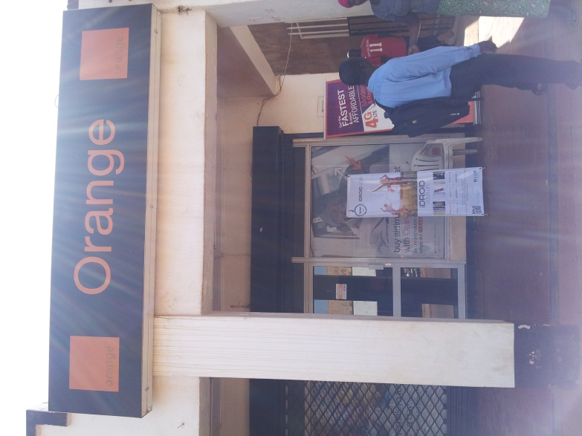

Orange shop

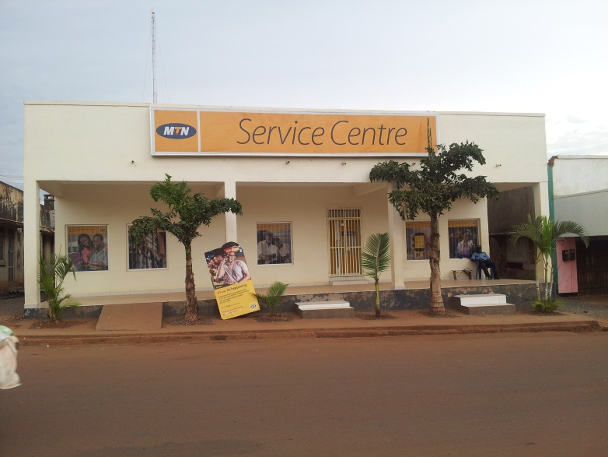

MTN shop

Public Internet
There are also a few places which reliably have wifi in case you want to go out and don't want to bring the modem: The Bomah Hotel, Sankofa Cafe, and The Coffee Hut. There is absolutely no wifi at the hospital. Which means those of you who rely on UptoDate regularly might find yourself a little crippled. Bringing Pocket Medicine or Approaches to Internal Medicine will probably be useful. I personally used the Medscape app which you can download ahead of time and get the offline clinical reference to use whenever you're not online (app-based resources are slightly easier to search).

Devices
Definitely bring a laptop or tablet - the house is a safe place for them. I opted for a tablet with a keyboard as a light option, but know that if you plan on doing any heavy photo/document processing that you will want a laptop. It will be useful to keep in touch and answer the bazillion medicine emails you will continue to get as well as allow you to look stuff up on a more readable screen. Your main challenge will be navigating the power situation, but if you are smart with your usage and take advantage of charging time when you can, you will be fine.

FINANCIAL INFORMATION
Pre-departure Travel + Evacuation Insurance
The resident PAR-BC medical plan is good, but doesn't cover evacuation insurance. However, what might cover it is your travel rewards credit card (for those of you that have them - RBC Avion, Capital One Aspire, TD Aeroplan Infinite, etc.). Just dig into your CC policies a little bit and check what your travel insurance coverage actually is - both the type of coverage and the overall amount. Some of the cards don't even require you to purchase the flight with them. As an example, in my personal case, I have a BMO World Elite Mastercard which included evacuation insurance as well as $2,000,000 in coverage for 21 days and I was able to call and get an extension to 31 days to cover my trip end to end for only an additional $28 or something small (and I think they also upgraded it to $4,000,000 coverage in the process). It might just be another way to save yourself some cash. Most of the travel credit cards come with a minimum of 15-day travel insurance and anywhere from $1-5,000,000, but it is always backed by an underwriter who you can call and get an extension for a nominal fee. It usually doesn't cover you doing anything Y-chromosome stupid like skydiving or rafting so just be careful about what you engage in (i.e. don't try to mate with a lion).

"Immediate" / Landing Costs
Here are some up-front landing-associated costs to know about:
- Ugandan entry visa - $50 USD at the Ugandan point of entry - you do NOT need to arrange this yourself beforehand, but have exact USD ready in case they don't have change.
- Overnight stay in Entebbe: I would say budget somewhere between $125-150/night for this. You will be able to access an ATM or foreign exchange in Entebbe if you want to walk a bit, so you can plan on that. The two main guest houses are Karibo Guest House (email: night@karibuguesthouse.com | $125/single-occupancy room) and Boma (email: thebomaentebbe@infocom.co.ug | $142/single-occupancy room). For booking - just email them (at least a week in advance) to make a tenative booking. For us, we stayed at the Karibo House which was quite nice - but farther away from the more central parts of town whereas Boma might be more central (and slightly louder). There is otherwise not too much in Entebe, so you might not be missing that much. I think you could probably also stay in Kampala, but getting there would be tricky, as there will likely NOT be complimentary airport pickup.
- Entebbe -to- Gulu ground transportation (driver: Bosco | boscoringtho@gmail.com) - $240 USD
The best thing to do is to have a large sum of USD to ensure that the above costs are covered, but also realize they will be your best exchange fund when it comes to paying for Safaris (see below).

Other "Living" Costs
Most of the housing costs should be taken care of and you will only be responsible for the consumables. Just FYI:
- stove gas cost (should be reimbursed by Marian Surgenor): 18,000 UGX + 2,000 UGX transportation
- water (you're on your own): 13,000 UGX + 2,000 transportation (ask Dennis to do it - just give him $)
- peanut butter: 15,000 UGX / 500g - random price point listed, I know, but delicious versatility
- pineapples @ Nixon's street pineapple stand: 2,000-3,000 UGX/each and he will cut them for you (they are delicious)

Foreign Exchange
Using your USD to obtain UGX at Foreign Exchange areas are also good options, but I would caution against doing too much of that and using up your USD more than what you immediately need (i.e. do it only if you cannot immediately access an ATM and need money). Here is an example of the rates you might see:
- Xpress Money - Entebbe (Jan11th): USD >$50-bill, buy 2780 / sell 2875; USD <$50 buy 2400 / sell 2875 (market rate on day: 1 USD = 2853 UGX)
- Western Union Foreign Exchange - Gulu (Jan13th): USD >$50, buy 2800, USD <$50, buy 2400 (market rate on day: 1 USD = 2870 UGX)
As you can see, you'll get a better rate with bigger USD bills, so think about stealing/asking/trading for denominations >= $50.
Only certain banks will change money for you. We ended up going to 3 different banks the first day trying to exchange money, and the one who would had a long lineup as the teller is doing normal banking too. I used the Umoja foreign exchange office (see map) which was no lineup and used a counting machine to count out the shillings for you so you feel comfortable with the amount given.

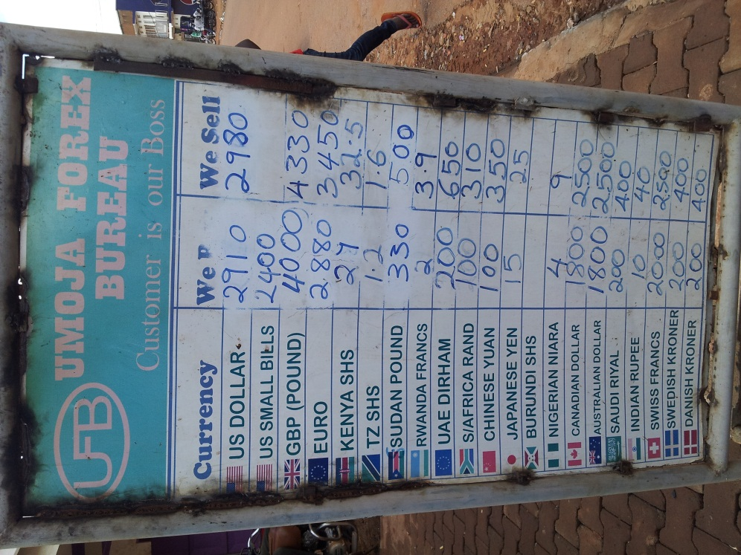

Typical exchange rates. As you see USD get you the best rates, even if you change your Canadian to US before you leave.
USD
USD will be your best (currency) friend on this entire trip. I brought $500 USD, but I would suggest bringing at least $1000 USD if you plan on doing any safaris because it will probably save you a few dollars overall on the exchange (we were given an exchange rate of 1 USD : 2850 UGX) compared to withdrawing straight UGX from your CAD account. I haven't actually sat down to do a price comparison (and likely won't), but my intuition tells me bringing more USD would be a smarter choice. If you are a money ninja and are good with securing your $ in various hiding places, bring even more. Otherwise, I think $1000-1500 would be good and just look at an ATM for UGX for petty spending when you hit the ground.
***Make sure your money is dated on or after 2009 and has NO rips, tears or writing on it. Noone will take it if it is.*** A good place to change to USD is the Vancouver Bullion Exchange at South Granville and 10th. Their rates are very favourable.
ATM
As you may have heard from Meghan, Scotiabank/ING has an alliance with Barclays. I believe ING "Tangerine" accounts are free with no service-charges, but initially Phil and Meghan had some hiccups in Uganda with being charged ATM service-charges (which then seemed to rectify after a lengthy international call discussion where Meghan exerted her verbal dominance over the entire banking system). I am not sure if this fix is going to be long-standing, but so far so good. Alternatively, if you open a Scotiabank account, you will be able to make withdrawals from a Barclay's bank account without any service charges. The account you want is called the "basic banking" chequing account which will run you about $3.95/month for having a balance under $2000, but will enable you to get 12 ATM (service-charge-free) withdrawals per month. There is also a cancellation charge of $20 if you cancel before 3 months is up, so you might want to open an account early and just let $2000 marinate in there. This latter option was the route I took given that I did not have access to an ING branch near me. I basically floated $3000 CAD into my Scotia account and withdrew from it whenever I needed UGX, planning on eating the monthly service fee and canceling right at the 3-month mark (which is why I would suggest keeping the balance small unless you have lots of cash to spare - then keep your balance above $2000 including planned UGX use).
Janet: I used my CIBC account at Barclays and had no trouble withdrawing money. However there was a 16,000 UGX service fee (about $5).
Budgeting
This obviously depends on how much you want to do there, but here's a quick breakdown of what you might expect:
- flights - ~$2000 CAD (covered by Program)
- 1st night in Entebbe post-flight - ~$125-150 USD (covered by Program)
- travel Entebbe -to- Gulu - ~$240 USD shared (covered by Program)
- house groceries/water/toilet paper - ~15,000 UGX/week
- lunch daily - anywhere from ~500-10,000 UGX/day* (if you settle on rolexes, plan for ~1,500 UGX/day)
- dinner daily - anywhere from ~7,500-25,000 UGX/day*
*if you budget for ~20-25,000 UGX/"full" meal (i.e. non-rolex/chapati street food), you should be okay even if you splurge on nicer meals now and then or decide to take advantage of the great juice selection. In this context, a "full" meal is one where you might sit down to eat in a restaurant and not the typical street food vendor lunches that you will likely get during weekdays working (which are also, delicious, btw). Then, you can also account for:
- safaris - estimate ~$500 USD/weekend for big trips and even more upwards if you upgrade accommodations
- travel Gulu -to- Entebbe - ~$240 USD (covered by Program)
- pre-flight night in Entebbe (or Kampala or wherever) - ~?$125-150 USD (covered by Program)
- technology - 40,000 UGX (internet shared) + 5,500 UGX (SIM + balance) will be more than enough I think
- whatever souvenirs you might want to get
- TIPS! (UWA ranger guides, trip drivers, tour operators, etc.)

IMPORTANT / USEFUL CONTACTS
Dr. Amanda Hill (UBC International Health Program Director) | cell: 7783898793 | email: amanda.hill@vch.ca
Bosco Ringtho (private hire driver) | boscoringtho@gmail.com
Entebbe Accommodations
The Boma, Entebbe | thebomaentebbe@infocom.co.ug | $142/single-occupancy room
Karibo Guest House, Entebbe | email: night@karibuguesthouse.com | $125/single-occupancy room
Marian Surgenor (UHSM Manchester Group Contact/Coordinator) | mobile: +44 (0) 79716 60042 | Marian.Surgenor@postgrad.manchester.ac.uk - she is the main Manchester contact person and overall coordinator for the house
*Dr. Jean Mensz (Peace Corp. MD - Internal Medicine) | phone: 0772139726 (burner cell) | email: jcmartin3@gmail.com
*Dr. Tessa Pierson (Peace Corp. MD - Family Medicine) |/ 0790553386 (iPhone) | email: tessa.pierson@gmail.com
Mr. Alfred (head of laboratory, GRRH) | phone: 0772961477 - you can also find him in person in the lab; I have never called him myself
Lumumba Sampson (ambulance driver) | phone: 0774017081 - I am actually not sure what to do with this information
Ben (private hire) | 0717595604 - I do not really know who this is; I think he is a driver you can hire for stuff
James Opiro (Director, Northern Nature Tours) | cell: 078-206-2311 | northernnaturetours@gmail.com

*You might want to fire the Peace Corp MDs and James an email before you leave Vancouver just introducing yourself and when you might be arriving.

Language
Most people in Gulu speak Acholi and English is often not understood by many patients, thereby making translators imperative. Occasionally you will run into other dialects... good luck. Practice your medical charades while you can. Be sure to figure out which student nurses and med students speak Acholi, as this is the only way you will ever get a history on your patients. If you haven’t already, you will learn the importance of history!

Food
Ugandan food typically consists of rice or chapati in a chicken or beef stew/broth; however there is enough selection around that you shouldn't get too bored of the food. It can be very cheap - anywhere from 6,000-20,000 UGX for a dinner entree and 5,000-7,000 for a fruit juice/iced coffee. Bringing some small snacks is a good idea - sometimes you will go long(er) durations on safari between meals. You might want to bring your favourite tea or (instant) coffee, as you won't be able to find that here. Same goes for sugar if you really like brown or white sugar - they mostly have raw sugar here. Fruit is REALLY cheap (you can get a whole pineapple - pre-cut for you if you want - for 2,500 UGX which is about $1.00 CAD).
Janet: we have been cooking in the house with success. However it is small, the fridge is a bar fridge and the propane stove requires matches. There are supplies like cooking oil, some random spices, sugar salt and pepper. Most restaurants serve fairly carb-heavy food so you may want to practice your cooking on-the-fly skills.

FUN WEEKEND THINGS
Safaris - Murchison Falls
We did a 3-day, 2-night trip out to Murchison Falls National Park which included a couple game drives, a walk to the actual falls, a Nile River boat ride (lots of hippos and crocs), and on the way back, we hit up the Budongo Forest Central Reserve for chimp tracking as well as the Ziwa Rhino Sanctuary for, well, rhinos. The latter two things are not normally done, but can be included by talking to James who will craft out a custom itinerary for you. Cost was priced together (below).

Safaris - Kidepo National Park
This was another 3-day, 2-night trip out to Kidepo National Park which is a bit more secluded and less travelled than Murchsion Falls. Camping in tents under the African sky with a nice campfire going was a really cool experience - highly recommended. We also saw big cats here! It seems that they are a little bit easier to find in Kidepo than Murchison from what others have also told us. Plus James will likely come along and cook for you! Cost below.

Northern Nature Tours via James Opiro
We did both of the above trips with James Opiro, who is the "director" (he is almost a one-man show) of Northern Nature Tours, a company he started in 2012. James is really a solid stand-up guy who will go the extra mile to take care of you. We talked to him about both of our trips and priced them out in sort of a package deal. We were essentially quoted $1150 USD for both trips, but the trouble with this is that the UWA park fees are always changing, so don't necessarily take our quote as the be all and end all. We managed to save quite a bit of money by combining our Kidepo trip with another 6-person group who wanted to come, so you should also give that some consideration. James does not take a large margin on these trips, as he is mainly trying to make a name for himself right now. If you ask him for his best price, he will give it to you and will treat you like family thereafter. You cannot go wrong with James - I fully endorse him. He will even argue with local staff if he thinks you have been ripped off over a meal (I witnessed him doing this for another traveller and he obtained a refund for her). If you have time, ask him about his life - you will find that he really has made the most of his circumstances, so I really have a lot of respect for that as well.
- James Opiro
- cell: +256 (0) 782 062311 [when in Uganda: just 078-206-2311]
- northernnaturetours@gmail.com
- www.northernnaturetours.com
The UGX:USD exchange rate that he used with us was based on what the UWA parks were using which was 2850 UGX to 1 USD. Keep that in mind when you go back and try to figure out how much USD to bring vs. the tradeoff of withdrawing UGX from an ATM. Maybe think about sending him an email with a tentative plan on meeting him day1 or 2 after landing to get your trips organized.
Entebbe
We also randomly got the contact of one of the boat captains in Entebbe who offered to take us out on Lake Victoria. We never took him up on this offer, but in case you are interested: Henry Kabugo | lakevictoriaislandstours@gmail.com.
Jinja - Rafting!
On our way back, we stopped in the small town in Jinja for some souvenir shopping and I also went rafting while the rest of my party shunned for me schisto exposure. All of the local companies have the same rate $125 USD, but I found that Nalubale Rafting (bookings@nalubalerafting.com) was willing to give me a small discount ($115) for not using their own accommodations - so I went with them and loved it! They are also literally around the corner from where we stayed, “Source of the Smile Guest House (Kiira Road Plot 39, Jinja, Uganda) which was a great find by Meghan.

The other big rafting company is Adrift Rafting (info@adrift.ug) and they run a bigger operation than Nalubale. I don’t think you can go wrong with either, as they are all very experienced, putting safety first. If you have more questions about this, email me directly and I’ll do my best to answer.

**There is a Bradt Uganda travel guide passed on from Julia Iosfina that we will leave here in the house (Lonely Planet-like type of guide).

LOCAL RECREATION
Acholi Inn (Pool)
There is a rectangular-shaped pool that is probably better for laps that you can use for 10,000 UGX/day or 80,000/month (9am - 7pm). I only scoped this place out, but Meghan who has been there before really gave the changing facilities a terrible review and said and overall less optimal experience. When I inquired about their gym, their manager told me "not to bother"... speaks for itself.

Bomah Hotel (Pool, Aerobics, Massage, Sauna, Gym)
The Bomah is like the palace of hotels in Gulu. It has a great pool (albeit probably better for playing than swimming laps) equipped with an elephant that sprays water out of its trunk. The elephant is a statue - don't get ahead of yourself now. It also has a very well-rounded gym with 3 treadmills, 3 stationary bikes, and a full set of free weight dumbbells with a barbell bench with some machines. The only thing it's missing is a squat rack. The pool is open from 9am - 7pm and the gym from 6am - 9pm. Your access fee comes with a towel, soap, good washroom facilities, and free water at the gym! Costs are below:
- gym - 10,000 UGX/time
- swimming - 10,000 UGX/time
- gym + swimming - 15,000 UGX/day
- gym + aerobics - 150,000 UGX/month
- gym + swimming, sauna, steam - 250,000 UGX/month
If you notice above, there is no gym monthly rate, however, if you talk to the health club manager, Sam, and explain that you are like your other Canadian friend, Morgan (he should remember me), he will give you a gym monthly pass for 100,000 UGX. I seriously worked out every day minus safari trips after I got that pass. Nothing like a workout, shower, and the application of DEETodorant... The Bomah is also only a 7 or so minute walk away from your home base - really no excuse not to come home absolutely shredded.

LOCAL EATS/ Shops
See the map below for some of these.

Uchumi – the big supermarket on Gulu Rd. They sell frozen meat, milk, very mediocre bread, lots of canned and bottled goods, breakfast cereal, drinks, toiletries including toilet paper, feminine hygiene, etc. The prices are relatively high compared to smaller shops but it is by far the biggest shop and has the widest selection of Western goods.

Market – open air market stalls/ Farmers market. As you walk down Gulu road you will see the stalls on the left hand side with many clothing stalls with hanging or huge piles of random clothes, shoes, old electronics. If you walk in about 100m and turn right you’ll see the farmers. The mostly ladies sell tomatoes, okra, eggplant, peas, or whatevers in season. If they have veggies stacked up you MUST buy the items in the little groupings of say 4 tomatoes or 8 okras. Do not pick the best ones from the groupings, you will be yelled at by the seller (ask Calvin). However you can pick what grouping you want Usually the prices are about 1000UGX for 4 roma tomatoes or a cabbage, or a cup of peas.
There are also many women who sell fruit and veggies at the crossroads of Awere and Jomo Kenyatta. They set up in the late afternoon/ evening and often stay until dark. The quality is very good and fresh.

"Robert's Chapati Street Stand" (I made this name up) - main hospital entrance by Police Canteen
Chapati 500 UGX // rolex (chapati rolled up w/ eggs) - 1500 UGX
We pretty much ate rolexes every day. Cheap and fast deliciousness.

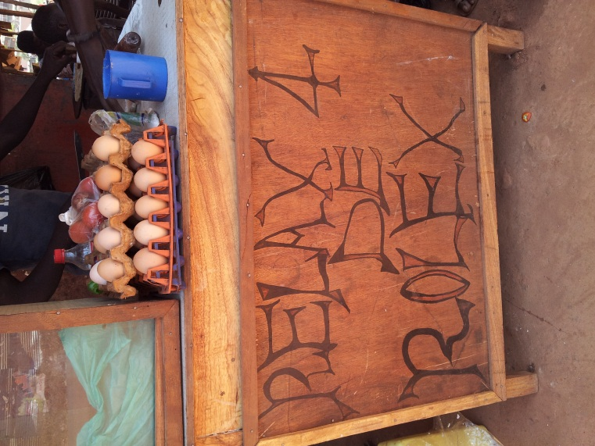

“AM Walk Corner Street Stand” - on the first turn onto Awere Rd walking to the hospital in the AM
mandazi (fried Ugandan donuts) - 200 UGX // chaptai - 500 UGX // rolex - 1500 UGX
*this was our backup on days Robert let us down and didn’t set up
The Kitchen - South on Awere Rd., take a right on Market Road
- 15000 UGX for 2 starches + 1 meat + 1 veg
The Bomah Hotel Restaurant - down Peter Paul Apok Rd (the street the house is on), turn right going North, then another right onto Eden Rd
- pricey, but good food, and free wifi + power!
- 6-minute walk from Home
- also hosts a gym + swimming pool + sauna + steam room
Sankofa
- probably the best local wood fire pizza place
- a bit far, but worth it for the food + juice
- I would recommend trying the chicken masala
Anna's Food Place - South on Awere Rd, turning left when you pass the new Market being built, then right immediately on the next road east of Awere Rd
- great (but very slow) indian food; consider calling ahead and placing your order
- there is a full menu for this place in the house
- theoretically has wifi but we have never been successful
Iron Donkey - beside Anna's Food Place, on the parallel road east of Awere Rd
- American style coffee/bakery place, is a bit pricey
- often the owner gives out free samples
- NO wifi
- free water
- great sandwiches + smoothies
Absynnia - located on Awere Rd, keep walking past the new Market being built
- Ethiopian place, really great food and remarkably inexpensive
The Coffee Hut - Awich Road (3 roads West of Awere Rd), past Jomo Kenyatta Rd
- great, great, great drinks (especially fruit smoothies, and MILKSHAKES - yes, pasteurized milk is used, etc.) Excellent Iced coffees!!!
- food is typical burger/sandwich/wraps that are very good too
- has ice cream!
- great place to hang out for meals or even just drinks because they have free wifi and air con!
- Tom is the owner and is a great guy as well… but sometimes he will yell at his employees which makes things get awkward reaaaally fast

Country Bakery – next door to the Coffee Hut, much better bread than the Uchumi at a better price, also excellent samosas and cakes, they supply the Coffee Hut (through a window where they pass things over) and the the Hut charges 40% extra for it.

Hotel Free Zone - straight down Awere Road) @ Market Road, it is the hotel with a giant horse statue outside
- serves buffet dinner for 15,000 UGX (1 plate of self-serve food + 1 soda)
Cafe Larem - On the unnamed road before Coronation Rd (2 roads west of Main Rd) terminates at Acholi Rd (beside “Butterflies Restaurant, Bar, and Lounge”)
- also makes a mean frapp
- typical american continental breakfast served
BJ's - east on Peter Paul Apok Rd from the house then turn North at first intersection
- bar that hosts trivia night every Thursday
- probably the closest night time social scene to home

THE WORK - GULU REGIONAL REFERRAL HOSPITAL (GRRH)
The Ward
The main Medicine ward consists of a Male (~22 beds + side room) and Female ward (~? beds) as well as TB ward (~5? beds) attached to the Female ward behind the wooden door up the ramp(sorry no negative pressure here- the charge nurse often yells at the patients and families to keep the door closed as they walk through the female ward to go outside.

Students
There are medical students, clinical officer students and nursing students around. Clinical officers are non-physicians who have a 3 year program and then work often in health units doing more or less what GPs do. See some of the sitreps regarding their curriculum and teaching (or lack thereof). There are two clinical officer schools in Gulu, a public one and a private one. The first school has blue nametags and the second school has green nametags. The medical students usually wear white coats and red nametags and look similar to the interns, but are less directed and “hover” more. The student nurses are dressed in green outfits. You can mobilize both of them as your resources to help: translate, do vitals (they have to be told to do it - vitals are not a routine thing, although I am trying to train them into making it routine), draw bloodwork, hang iv solutions, insert iv, take samples to the lab. I usually try to do teaching with both medical students and nursing students to keep them engaged. I find showing them interesting physical findings works well and then explaining some of the physiology behind it. For nursing students, I try to focus more on patient assessment because they don't get a lot of teaching on this (they are taught mainly how to administer meds and other technical skills like doing ivs/bloodwork). I often ask MSIs to examine patients fully and report back. Tessa and Jean (Peace Corp MDs) have really built the medical student curriculum up in their own vision… also because no one else is doing it - so touch base with them to see how they want to run things with the MSIs.

The Lab and Available Investigations
The lab is located a short walk away from the Medicine ward. You, or someone else, has to physically bring samples to the lab for processing. Each sample must have a lab request sheet as well as a labelled tube with patient name and test requested. The tests you can get routinely that we have seen are:
- CBC+diff [purple tube]: quite reliable - get this back most of the time
- CD4 [purple tube]: unreliable - get this back only some times
- point of care / bedside HIV test [RN to do]: only done by RN - you will have to chase them down for it and make sure they use the right reagents (if saline used as buffer, positive control does not light up!)
- Renal Function Test (RFT) = Ur + Cr [red tube]: get this back some times (sometimes reagents unavailable)
- Na + K [red tube]: I have asked and been told these can be done, but have ordered these multiple times and never received results ever
- Liver Function Tests (LFTs) = ALT/AST/AP/GGT/Alb/d+t-Bili [red tube]: get this back most of the time, but slow
- gram stain (on anything) [sample container]: get this back most times
- AFB [sample container]: get this back most times
- UA [sample container]: get this back most times
- Hep B sAg [unsure what color tube]: has never been done for us as no reagents
- *there is no ability to do a C&S
Everything else you would have to try to get the patient to pay an outside lab to do it - lab tests can be anywhere from 1,000-3,000 per test and as far as I know you can do HepB sAg, H. pylori Ab, Mg, Ca, PO4, but I'm not sure if you can do anything else.

Radiology
As of January 2015, the X-ray machine is broken, so patients cannot get x-rays without paying privately for them to be done elsewhere. Some of them can afford it so keep an eye out for big paper envelopes containing their films. Your light box will be the sun… X-rays and U/S typically cost 20,000 UGX/each which is quite expensive. You can also get ECG and ECHO on site from Dr. Aliku (Pediatric Cardiologist) - just send him a consult req and I have heard it is free (otherwise he charges his outpatients a nominal fee).

Consultants
You will have access to General Surgery, Ophthalmology, ENT, Palliative Medicine, Cardiology (there is a Pediatric Cardiologist who will sometimes help out), Physiotherapy, Occupational Therapy, Orthopedics… and not much else.

OTHER OPPORTUNITIES - LACOR HOSPITAL
(pronounced "La-cho")
St. Mary’s Lacor Hospital is a private hospital in Lacor just on the outskirts of Gulu which may give you a comparison as to what additional resources would be available there. The best thing to do is probably to coordinate with the Peace Corps MDs to go out there for a couple days day just to see and compare the difference. It hosts its own set of interns (completely separate from the Gulu interns), but I believe the medical students are shared. There is a University driver who should be able to get you there and back (ask the Peace Corps MDs) otherwise you might have to get a private hire/public bus. Overall, this site has a lot more resources like GI endoscopy, bronchoscopy, etc. but still does not have a CT-scanner.

MAP

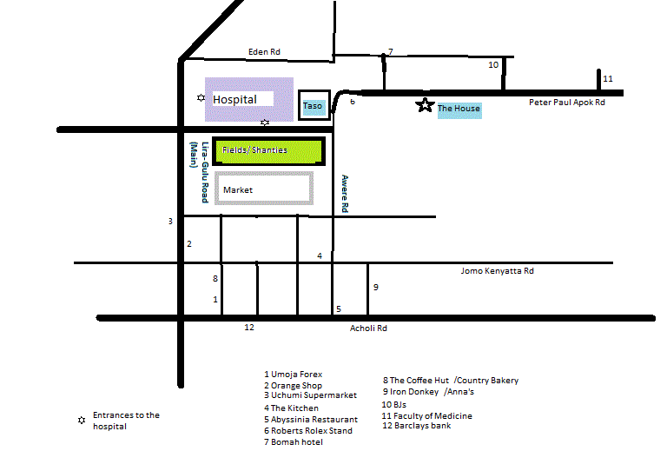

SPECIAL STUFF TO BRING
Medical Gear
- PPE!
  - N95 x 2 boxes (enough to use ~2+/day)
  - nitrile gloves x 1 box (probably enough)
  - sterile gloves (5 pairs or so in your size - they have lots in 7.5) mostly to do LPs
  - hand sanitizer (1 bottle for yourself will probably last 4 weeks, but they frequently run out, so maybe bring up to 3-4 for the rest to encourage ahdn hygiene habits)
  - alcohol wipes (to clean stethescope)
- Thermometer, BP Cuff (they only have 2-3) + O2 sat probe (they have zero) would be useful
  - bringing any old supplies that you no longer want would be helpful
- White coat (optional obviously, but all interns wear them - useful to store some PPE)
- ID badge, stethoscope, reflex hammer
- ultrasound jelly for donated GE v-scanner (1 bottle each group) + appropriate U/S wipes (make sure they’re not the ones that dissolve the probe)
- lidocaine for procedures (they don’t always have it or use it)
- Glc strips (they frequently run out and don’t have any to use on patients)
Janet: as of March 2015 there are a ton of N95 masks, swabs and sterile gloves at the house. Suggest each group check with the group before how much to bring and what supplies are needed. We found the most useful items would have been personal BP cuffs, oximeters and thermometers so you don’t need to share when you’re running around.

Fun Stuff
- card games! (we totally dropped the ball on this)
Safari Specific
- binoculars as per Dr. Hill :)
- bird book/guide (James Opiro will also have one)
- *if you bring a dSLR, consider bringing a fast 300+mm lens (f3.5 or faster) +/- mono/tri-pod; I had a f3.5-5.6 200mm lens and did okay, but definitely missed some of the animals that were farther and really started to suffer in suboptimal light conditions
- think about acquiring a spare camera battery if you can; there is often power, but sometimes it can be sketchy
- consider a spare CF/SD card if you plan on taking a lot of photos (especially if you are shooting in RAW); I bought a 32GB one and blew ~800 photos
- The mosquito nets at the rest camps are pretty dicey. Bring tape.
Miscellaneous
- old tupperware to donate to the house (to prevent ants from getting into everything) – Janet: lots of Tupperware right now
- make sure you bring a water bottle (maybe 2, one being bigger - 1.5L or so) including something you can bring to the hospital

